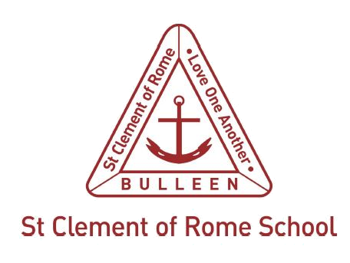
Child Abuse Support Resource 3

St Clement of Rome Catholic Primary School procedure for ensuring that staff are informed about mandatory reporting obligations
As a duty of care, the staff at St Clement of Rome Catholic Primary are mandated to report on child abuse when this has been disclosed to them or they have formed a reasonable belief that abuse has occurred.
Child abuse is defined in the Child Wellbeing and Safety Act 2005 (Vic.) to include:
- sexual offences
- grooming
- physical violence
- serious emotional or psychological harm
- serious neglect.

Mandatory reporting, failure to disclose and failure to protect
- The mandatory reporting obligation is set out in Part 4.4 of the Children, Youth and Families Act 2005 (Vic.). Section 184 imposes an obligation on teachers, principals and other persons listed in section 182 to make a mandatory report if they form a belief on reasonable grounds that a child is in need of protection on the grounds that the child has suffered, or is likely to suffer, significant harm because of physical injury or sexual abuse, and the child’s parents have not protected, or are unlikely to protect, the child from harm of that type.
- Ministerial Order No. 870 (accessible) sets out the specific actions that registered schools need to take to meet the child safe standards. The Ministerial Order places accountability for managing the risk of child abuse with school governing authorities.
- The failure to disclose offence requires any adult (subject to specific exemptions) who forms a reasonable belief that a sexual offence has been committed by an adult against a child under 16 to report that information to police. Failure to disclose the information to police is a criminal offence. Further information can be obtained at: www.justice.vic.gov.au/safer-communities/protecting-children-and-families/failure-to-disclose-offence.
- The failure to protect offence applies where there is a substantial risk that a child under the age of 16 under the care, supervision or authority of a school will become a victim of a sexual offence committed by an adult associated with that school. A person in a position of authority in the school will commit the offence if they know of the risk of abuse and have the power or responsibility to reduce or remove the risk, but negligently fail to do so. Organisations other than schools are also covered by the offence. Further information is available at: www.justice.vic.gov.au/safer-communities/protecting-children-and-families/failure-to-protect-a-new-criminal-offence-to.
All teachers, those who are mandatory reporters and all other staff at St Clement of Rome Catholic Primary will be made aware of mandatory reporting requirements and potential offences for failing to make a mandatory report by:
- addressing the school’s policies and the mandatory reporting obligations at staff meetings on a regular basis
- using school-wide operational and classroom practices that embed a culture of child safety in our school
- having all staff undertake mandatory reporting eLearning sessions annually
- ensuring any new or trainee staff meet with the Deputy Principal for induction regarding school issues and mandatory reporting responsibilities
- displaying Child Protection posters in the staff room
- requiring all staff to sign a code of conduct that explains the expected and unacceptable behaviours for staff at appointment
- assessing the ongoing suitability of staff through discussion as part of the annual review meeting process.

