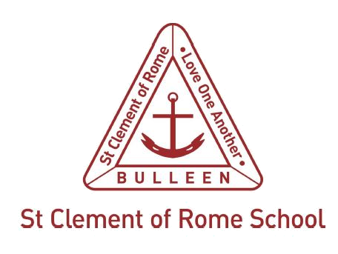

OHS Issue Resolution Flowchart
The following flowchart should be used for the resolution of workplace occupational health and safety (OHS) issues, providing an agreed process does not already exist.
This flowchart or the agreed process should be communicated to all employees and displayed in a prominent position in the workplace including on the OHS Notice Board.
The Health and Safety Representative is:
OHS ISSUE
Issue resolved?
NO
YES
YES
NO
Immediate threat?
YES
NO
NO
YES
YES
- Record resolution
- Report to staff meeting or Health and
Safety Committee
(if established)
- Inform affected employees of outcome
HSR may choose to Issue a
Provisional Improvement Notice (PIN)
If so, Principal or delegate notifies regional office
Stop-work direction disputed by Principal?
Contact WorkSafe
NO
Issue resolved?
Principal or delegate notifies regional office
Stop work direction by HSR and/or Principal

Agenda item for staff meeting
or Health and Safety Committee
or for further advice, contact:
Melbourne Archdiocese Catholic Schools
OHS Team, Tel: 9267 0431
Notify HSR.
HSR informs relevant management to discuss issue.
Employees nominate a representative to discuss issue with relevant management.
Is there a Health & Safety Representative (HSR)?

