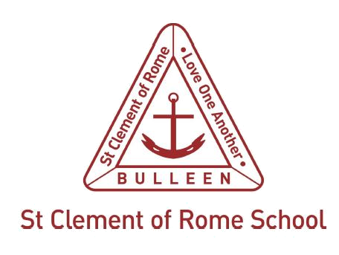

Duty of Care Guidelines

Purpose
Melbourne Archdiocese Catholic Schools Ltd (MACS) in partnership with parents, guardians and caregivers, who are the primary educators of their children, is entrusted with the holistic education of each child in our schools. All staff therefore have a duty of care to students to take reasonable care to avoid acts or omissions that they can reasonably foresee would be likely to result in harm or injury to the student, and to work for the positive wellbeing of each child. The Education Training and Reform Regulations 2017 (Vic.) (sch 4 cl 12) require that schools must ensure that the care, safety and welfare of all students attending the school is in accordance with any applicable state or Commonwealth laws, and that all staff are advised of their legal obligations under those laws.
Duty of care is an element of the tort of negligence. In broad terms, the law of negligence provides that if a person suffers an injury as a result of the negligent act or omission of another, the injured person should be compensated for loss and damage flowing from that negligence.
To successfully bring a compensation claim in negligence, a person must establish on the balance of probabilities that:
- a duty of care was owed to them at the time of the injury
- the risk of injury was reasonably foreseeable
- the likelihood of the injury occurring was more than insignificant
- there was a breach of the duty of care or a failure to observe a reasonable standard of care
- this breach or failure caused or contributed to the injury, loss or damaged suffered.

The fact that a duty of care exists does not mean that a school will be liable for an injury sustained by a student or other person. In order to succeed in a negligence claim, all of these elements must be established.

Scope
Duty of care applies to all sites under the control of the school and applies to all members of the school’s leadership team, teaching and non-teaching staff members, casual relief teachers, religious and parish staff, volunteers and contractors engaged by the school.
Duty of care is a matter for the whole organisation. It is not just confined to the geographical area of the school but also to school activities that occur outside the school where a student is acting on a staff member’s instructions. The duty also applies to situations both before and after school where students can be assumed to be under the teacher’s care. Consideration must be given to the age and capacity of children in care with greater attention required for younger students or students with disabilities.
Teaching and non-teaching staff members owe a duty of care to students within their care, and, but not limited to, parents, student teachers, volunteers, visitors or contractors who may sustain injury, loss or damage as a result of our conduct.
The school owes a duty to take reasonable care that any student (or other person) on the premises will not be injured or damaged because of the state of the premises, including things done or omitted to be done to the premises.
Principals and teachers are held to a high standard of care in relation to students. The duty requires principals and teachers to take reasonable steps to minimise the risk of reasonably foreseeable harm from injury or child abuse to students by an individual associated with the school whilst the child is under the care, supervision or authority of the school.
Duty of care is non-delegable, meaning that it cannot be assigned to another party.
Whenever a teacher-student relationship exists, teachers have a special duty of care. Generally, teachers are expected to take such measures as are reasonable in the circumstances to protect a student under their charge from reasonably foreseeable risks of injury or child abuse.

Definitions
Duty of care is a legal obligation that requires schools to take reasonable steps to reduce the risk of reasonably foreseeable harm, which can include personal injury (physical or psychological) or damage to property. The reasonable steps that our school may decide to take in response to a potential risk or hazard will depend on the circumstances of the risk.

Principles
In having a duty of care to students, MACS schools will:
- ensure compliance with the seven Child Safe Standards
- provide suitable and safe premises
- provide an adequate system of supervision
- implement strategies to prevent bullying
- ensure that medical assistance is provided to a sick or injured student
- manage employee recruitment, conduct and performance.

Policy
Each MACS school has policies and procedures to manage common risks in the school environment, including:
- bullying prevention and intervention
- camps and excursions
- child safe standards
- codes of conduct for parents, students and staff
- emergency management
- employment and management of staff
- health and first aid policies
- mandatory reporting
- occupational health and safety
- student wellbeing and engagement
- supervision of students in class and in the school yard.

The principal and school leaders in MACS schools have the responsibility for ensuring that all staff, as well as support personnel, are familiar with the Duty of Care Guidelines and the implementation of relevant policies.
All staff and relevant personnel have signed a code of conduct in relation to child safety.
Parents are advised of MACS policies regarding supervision of students, including times for before school and after school supervision, through school communication. Reminders are issued at regular intervals. School staff, parents, carers and students are encouraged to speak to the principal to raise any concerns about risks, hazards or duty of care obligations.

