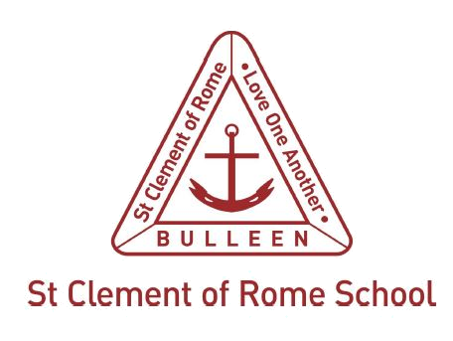

Student Code of Conduct
St Clement of Rome Catholic Primary is a school which operates with the consent of the Catholic Archbishop of Melbourne and is owned, operated and governed by Melbourne Archdiocese Catholic Schools Ltd (MACS), where formation and education are based on the principles of Catholic doctrine, and where the teachers are outstanding in true doctrine and uprightness of life.

Purpose
St Clement of Rome Catholic Primary is committed to ensuring a respectful learning environment that is safe, positive and supportive for all students of the School.
It is the intention of St Clement of Rome Catholic Primary to provide clear guidelines to all students regarding the conduct expected of them whilst at School, engaging in School related activities or representing the School. Students are expected to uphold the School’s core values at all times.

Application
This Code applies to all St Clement of Rome Catholic Primary students. The application of this Code is not limited to the School site and School hours. It extends to all activities and events that are school-related and when representing or acting on behalf of the School, including without limitation at all times when wearing the School uniform. The Code also requires that student actions do not bring the School into disrepute at any time regardless of whether the action occurs within or outside of School activities.

Basic principles
This Code of Conduct is based on the following Principles that everyone at St Clement of Rome Catholic Primary:
- has the right to be safe
- has the right to be treated with respect and be valued even in diversity
- has the right to participate within a secure environment without interference, intimidation, harassment, bullying or discrimination
- is encouraged to be respectful, polite, courteous and considerate of others
- has the right to be supported and challenged as ongoing learners.

Expected Conduct and Bearing of All Students principles
It is expected that every student will:
- uphold the School’s core values at all times
- behave in a manner that does not endanger the health, safety and wellbeing of themselves or others
- abide by all health and safety rules and procedures operating within the School and other locations at which the students may visit
- ensure that their actions do not bring the School into disrepute
- respect the authority of members of staff and observe school rules and teacher directions as required
- strictly adhere to the Student ICT Responsible Use Agreement
- be respectful and supportive of the school’s beliefs and values
- behave with courtesy and consideration for others.
- refrain from all forms of bullying, harassment, racial vilification and discrimination of any nature
- report any behaviour of other students that is harmful to other students or to the teachers or School
- support other students, or seek help for other students who need assistance or are in a vulnerable situation
- refrain from behaviour which would interrupt the work of any class or hinder the learning opportunities of other students
- respect school property and the property of staff, contractors, visitors and other students;
- be punctual and attend all classes
- remain in the School grounds during the School day unless otherwise approved by the Principal
- complete work set by teachers promptly and to the best of their ability and to take full advantage of the educational opportunities offered at the School
- dress neatly and with due regard for health, hygiene and safety in accordance with the School’s uniform requirements.

Unacceptable conduct
Unacceptable conduct includes, but is not limited to:
- touching, handling, pushing or otherwise physically or sexually engaging with students or others in a manner which is not appropriate and may endanger the health, safety and wellbeing of that person
- any form of physical or verbal violence including fighting, assault or threats of violence, bullying, name calling, racial discrimination or discrimination on grounds of disability, appearance or religion
- any form of cyber bullying or cyber abuse
- theft or misuse of property belonging to other students or the School
- sending inappropriate, offensive or explicit text messages, photos or videos
- language or conduct which is likely to offend, harass, bully or unfairly discriminate against any student, teacher, contractor or visitor
- the use of inappropriate or profane words or gestures and images
- unacceptable class attendance levels
- being uncooperative with teachers during class or school activities and generally disrupting planned activities.

Supporting Positive Behaviour
The School’s Behaviour Management Policy is based on a model of Positive Behaviour Support. This is a model that acknowledges the positive behaviour of the majority of students, puts strategies into place to model and specifically teach expected behaviours and targets focussed support (including staged sanctions) for the minority of students that do not embrace positive behaviour.

Breach of Student Code of Conduct
Students who breach the Code of Conduct may be sanctioned by the class teacher or school principal as deemed appropriate given the nature of breach and the age of the student. (cf. Behaviour Management Policy)
In cases of serious and /or persistent breaches of the student code of conduct the St Clement of Rome Catholic Primary Behaviour Management Policy outlines consequences for student misbehaviour and the management of suspension and expulsion if matters came to those extremes.
In accordance with applicable legislation and the School’s Child Safety Policy, the Police and/or Department of Human and Health Services will be informed of any unlawful breaches of this Code.

NAME OF STUDENT |  | Date:
SIGNATURE OF STUDENT |  | Date:
SIGNATURE OF PARENT / CARER

Related Policies
- St Clement of Rome Catholic Primary Enrolment Policy
- St Clement of Rome Catholic Primary Enrolment Form and Agreement
- St Clement of Rome Catholic Primary School Complaints Handling policy
- St Clement of Rome Catholic Primary School Behaviour Management policy

