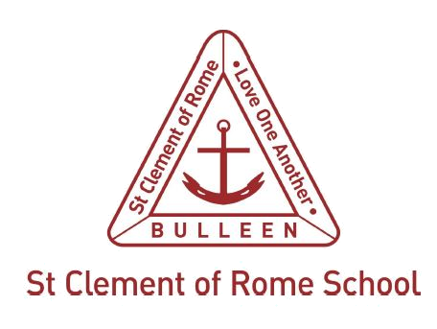

Dependant International Student Application Form

St Clement of Rome Catholic Primary is a school which operates with the consent of the Catholic Archbishop of Melbourne and is owned, operated and governed by Melbourne Archdiocese Catholic Schools (MACS), where formation and education are based on the principles of Catholic doctrine, and where the teachers are outstanding in true doctrine and uprightness of life.
STUDENT DETAILS
Family Name: |  | Given Name:
Date of Birth: |  | Gender:
Nationality on Passport: |  | Country of Birth:
Passport Number: |  | Expiry Date:
CONTACT DETAILS
Father’s/Legal Guardian’s Family Name:
Father’s/Legal Guardian’s Name:
Mother’s/Legal Guardian’s Family Name:
Mother’s/Legal Guardian’s Name:
Family Contact Number:
Family Email Address:
FAMILY AUSTRALIAN RESIDENTIAL ADDRESS
Street Address:
City: |  |  | State:
Country: |  |  | Postcode:

PARENT’S/GUARDIAN'S COURSE ENROLMENT DETAILS
Please provide copy of letter of offer and Certificate of Enrolment
Family Name: | Given Name:
Nationality: | Passport Number:
Visa Subclass: | Tertiary Institute:
Passport Expiry Date: | Visa Expiry Date:
Course Start Date: | Course End Date:

SIBLING DETAILS
Does the student have a brother or sister currently enrolled at a Victorian school? Yes No
If yes, which school are they attending?
Sibling name 1:
Sibling name 2:
Sibling name 3:

SPECIAL CIRCUMSTANCES
The more information you provide will assist to ensure that your child is provided with the most appropriate support according to their needs.
Has the student been diagnosed with a medical condition that a doctor should be aware of?
If so, please provide details:
Does the student have any special learning needs which the school needs to be aware of?
If so, please provide details:

EDUCATION HISTORY
In what country has the student been studying?
Current Year level: | How many years of English language has the student studies?

STUDY PLAN
Proposed Year Level:
Proposed Commencement Date: | Proposed End Date:

Checklist
The application process will not commence until the Dependent Full-Fee Paying Overseas Students (FFPOS) Application form is complete and all necessary supporting documentation is provided to the School for seeking approval from Melbourne Archdiocese Catholic Schools (MACS).
Copies of the following original documents must be provided:
- in the original language translated into English and
- certified as true copies of the original documents by an authorised person of the country concerned.

Copy of original document | English Translation | Certified as true copies of original | Document
n/a |  |  | Birth certificate or passport page
n/a |  |  | School reports including a grading key for the most  recent two years
 | n/a | n/a | A copy of the parent’s visa
 | n/a | n/a | Proof of medical conditions and additional learning needs (if applicable)

