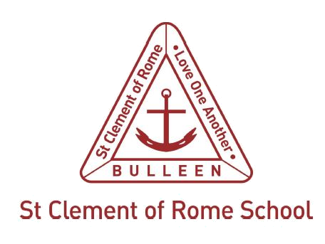

St Clement of Rome Catholic Primary

Essential Safety Measures Policy
St Clement of Rome Catholic Primary is a school which operates with the consent of the Catholic Archbishop of Melbourne and is owned, operated and governed by Melbourne Archdiocese Catholic Schools Ltd (MACS), where formation and education are based on the principles of Catholic doctrine, and where the teachers are outstanding in true doctrine and uprightness of life.

Purpose
We are called to be stewards of creation, caring for the gifts God has given us, including the environment, our own personal talents and resources. St Clement of Rome Catholic Primary is committed to ensuring the safety and wellbeing of members of our community to ensure that the school is an optimal environment for learning. The proper maintenance of the buildings, facilities and grounds is essential to the creation and maintenance of a safe and inclusive learning environment, and gives the school community confidence in the reliability of systems should an emergency arise.
St Clement of Rome Catholic Primary has a moral and legal responsibility to ensure the safety and wellbeing of members of the community. The Victorian Building Regulations 2018 (the Regulations) require that buildings are maintained so that they operate satisfactorily.

Scope
These guidelines apply to the buildings, facilities and grounds of St Clement of Rome Catholic Primary School are classified as Class 9b buildings in the Regulations (excluding any other parts of the building that are of another class).
There are different obligations under the Regulations, which depend upon when the school was built or when building work occurred on the building or buildings.

Buildings constructed before 1 July 1994
If the building was built before 1 July 1994, the owner is responsible for ensuring that any safety equipment, safety fittings or safety measures are maintained and fulfilling their purpose. This includes exits and paths of travel to exits.

Buildings constructed after 1 July 1994
If the building was constructed or altered since 1 July 1994, the list of essential safety measures, including their performance, frequency and type of maintenance required, would be included with the occupancy permit or certificate of final inspection.

Regulatory context
Schedule 4, clause 13 of the Education and Training Reform Regulations 2017 (ETR) states that a registered school’s buildings, facilities and grounds must comply with any laws that apply to the school including local laws and building, planning, and occupational health and safety laws.

Definitions
Essential safety measure is defined in Part 15 of the Regulations and includes items listed in Schedule 8 of the Regulations, such as:
- air handling systems (used for smoke hazard management)
- exit doors
- early warning systems
- emergency lifts
- emergency lighting
- emergency power supply
- emergency warning systems
- exit signs
- fire control centres
- fire curtains and doors
- fire extinguishers
- fire detection and alarm systems
- fire hydrants
- fire isolated stairs
- fire rated materials
- fire windows
- mechanical ventilation (incorporating a cooling tower, or hot or warm water system)
- fire isolated passageways and ramps
- paths of travel to exits
- smoke alarms
- smoke control systems
- sprinkler systems.

Policy
  - As the building owner, MACS requires that the principal prepares an annual essential safety measures report on the building’s essential safety measures. The Principal may authorise an agent, such as a specialist maintenance contractor, to complete the report. The annual essential safety measures report needs to be in accordance with the approved form.
  - Records of maintenance checks, safety measures and repair work must be retained so they can be inspected by a municipal building surveyor or chief officer of the fire brigade.
  - These documents must be available on request after 24 hours notice has been given.
  - If work is planned that will alter existing buildings, the impact on essential safety measures must be considered. Check with a municipal or private building surveyor to ensure that compliance with the Act and Regulations is maintained.
  - A current copy of the building’s occupancy permit will be displayed at St Clement of Rome Catholic Primary in a prominent position approved by the building surveyor.

Role of the principal or delegate
The Principal at St Clement of Rome Catholic Primary acts as the school’s site manager and is responsible for:
- occupational health and safety (OHS) affecting buildings, plant, classroom furniture and equipment
- general safety and environmental management
- soil and environmental contamination
- building ventilation
- noise
- rainwater tanks
- sanitation and waste collection
- swimming pools
- tree maintenance
- fire protection prevention
- bushfire preparedness
- general safety practices on site during a construction project.
The procedures St Clement of Rome Catholic Primary are consistent with the relevant Australian Standard and only incorporate approved playground equipment (and do not include seesaws, swings, maypoles, merry-go-rounds, roundabouts and flying foxes).

Consequences of failing to comply
Non-compliance could place students, staff and members of our community, as well as passers-by and the occupants of adjoining buildings at risk. Non-compliance may result in an infringement notice being issued by council or the Fire Authority, along with a fine. It may also result in prosecution and more substantial fines.

Related school policies
OHS Policy

