Child Safety Support Resource 1

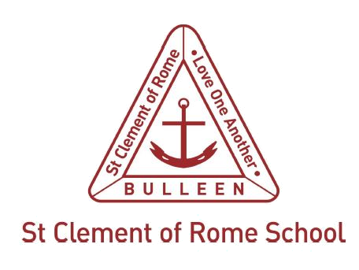

St Clement of Rome Catholic Primary School internal school process for mandatory report
Melbourne Archdiocese Catholic Schools (MACS) schools should develop internal procedures consistent with PROTECT and the Four Critical Actions referenced in the Policy. Schools may document these internal procedures below in a variety of ways, including a flow chart. The internal procedures must be readily available to all members of the school community, including on the public website.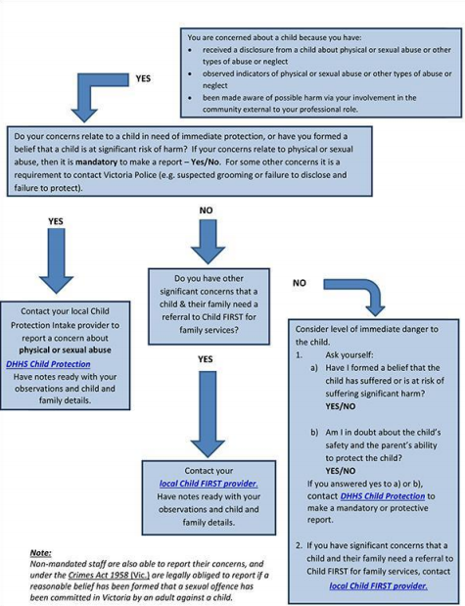ing

